**Carbon Table 2–Tracking progress toward carbon negative by 2030**

Microsoft’s overall emissions increased by 29.1% in FY23, in relations to our base year. Additionally, we retried 605,354 metric tons of carbon removal as part of achieving out annual target to be carbon neutral.

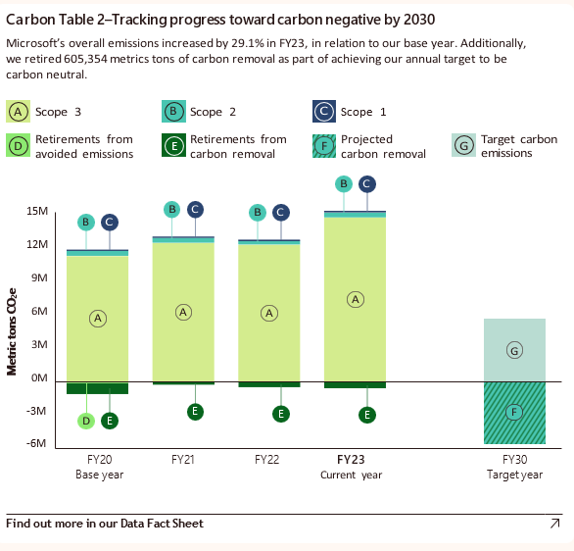

Bar graph showing the progress toward carbon negative by 2030 in terms of Scope 3, Scope 2, Scope 1, Retirements from avoided emissions, Retirements from carbon removal, Projected carbon removal, and Targeted carbon emissions. The x-axis represents years from FY20 to FY30 and the y-axis represents Metric tons of CO subscript 2 e ranging from negative 6M to 15M in intervals of 3M. FY20 is highlighted as the Base year, FY23 as the Current year, and FY30 as Target year. Out of all the emissions Scope 3 has the maximum emission followed by Scope 2 and Scope 1. with Retirements from carbon removal, and Contracted carbon removal in negligible amounts from FY20 TO FY23 and Retirements from avoided emissions in negligible amount in FY 20. Target carbon emissions is approximately 5m and Projected carbon removal is approximately negative 6m.